**What are the qualities in baby products that makes user dissatisfied with the product?**



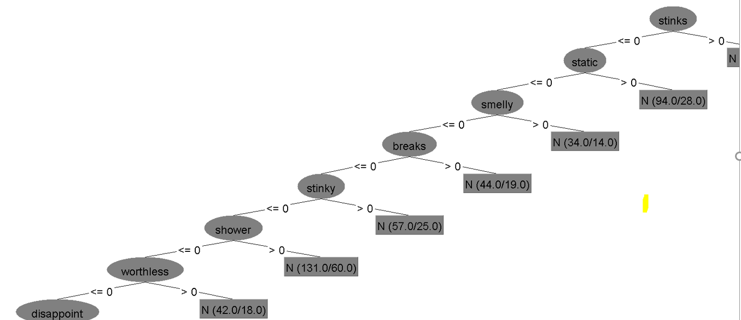

**Which baby products people usually prefer to give as a baby shower gift?**

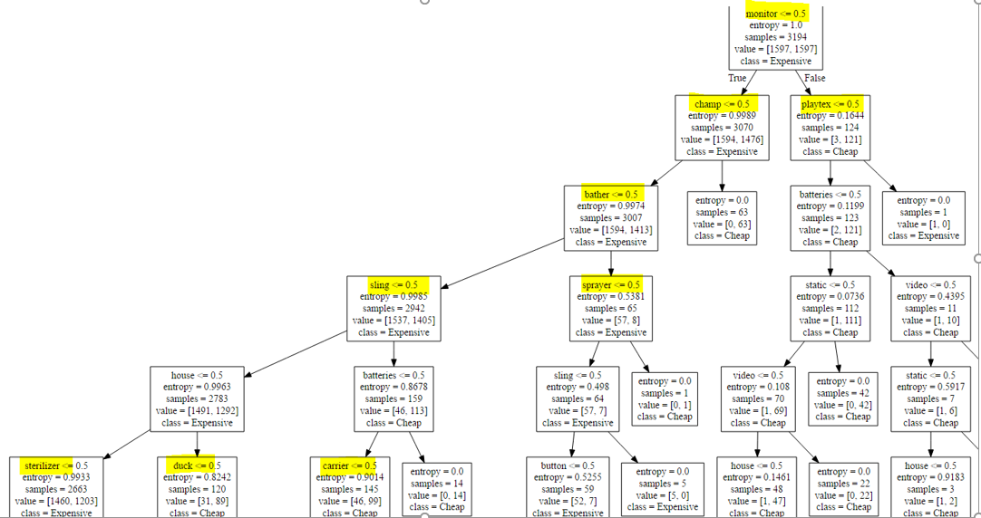



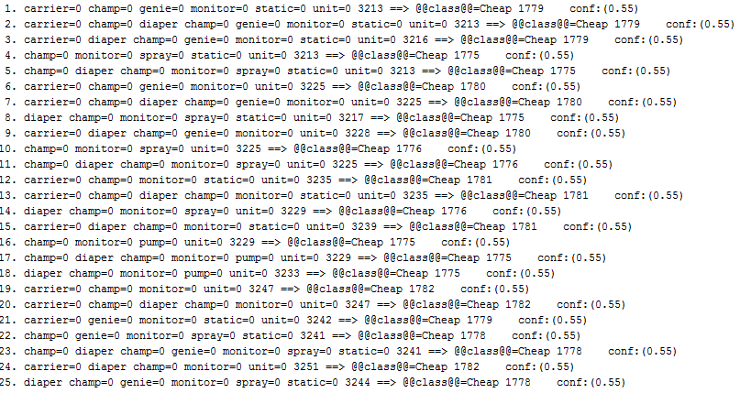

Products Details:

B00003TL7P- Baby Trend Diaper Champ

B000059XOD-BABYBJORN Original Carrier - City Black

B000056OV3-Playtex Diaper Genie - First Refill Included

B00004YUZ6-Prince Lionheart Electronic Mosquito Repeller, Prince Lionheart Pacifier Rinser